Project Design Phase-II
Data Flow Diagram & User Stories

Date | 26 February 2026
Team ID | LTVIP2026TMIDS80402
Project Name | Order on you go
Maximum Marks | 4 Marks

Data Flow Diagrams:

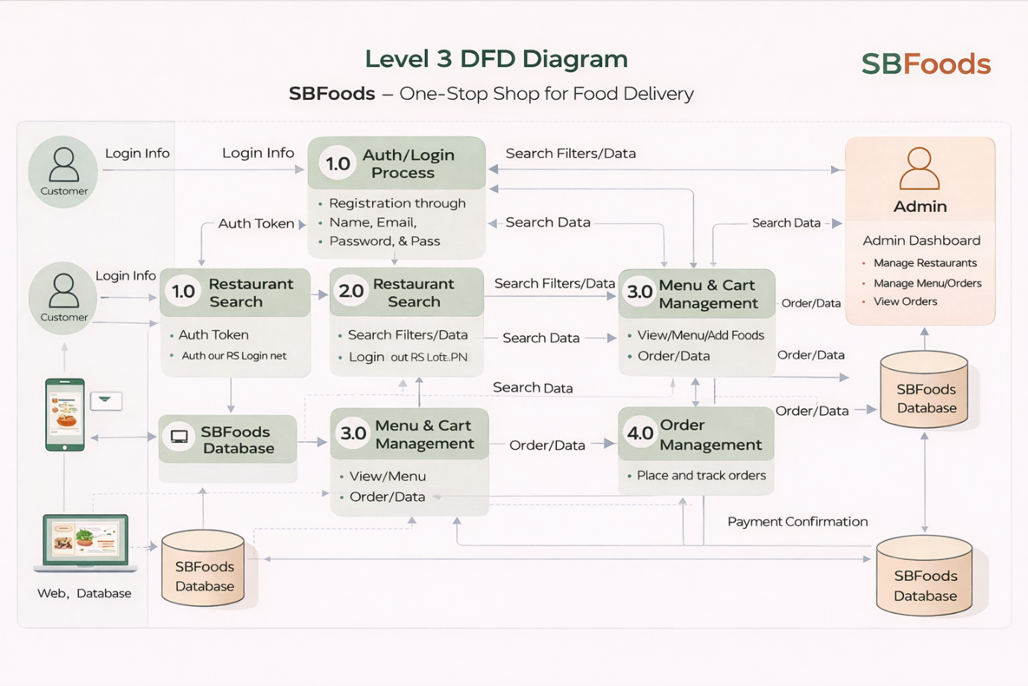

User Stories
Product Backlog & Sprint Planning (SBFoods)
Sprint | Functional Requirement (Epic) | User Story No | User Story / Task | Story Points | Priority
Sprint-1 | Authentication | US-1 | User can register with name, email & password | 3 | High
Sprint-1 | Authentication | US-2 | User can login securely using JWT | 2 | High
Sprint-1 | Admin | US-3 | Admin login with role-based access | 2 | High
Sprint-1 | UI | US-4 | Create homepage with category navigation | 3 | Medium
Sprint-1 | UI | US-5 | Display products by category (Fashion, Electronics, Sports, etc.) | 5 | High
Sprint-1 Total |  |  |  | 15

Sprint | Functional Requirement | User Story No | User Story | Story Points | Priority
Sprint-2 | Product Management | US-6 | Admin can add new product | 5 | High
Sprint-2 | Product Management | US-7 | Admin can edit/delete product | 5 | High
Sprint-2 | Product | US-8 | View product details page | 4 | Medium
Sprint-2 | Search & Filter | US-9 | Search products & filter by category | 6 | Medium
Sprint-2 Total |  |  |  | 20

Sprint | Functional Requirement | User Story No | User Story | Story Points | Priority
Sprint-3 | Cart | US-10 | Add product to cart | 5 | High
Sprint-3 | Cart | US-11 | Update/remove cart items | 5 | High
Sprint-3 | Order | US-12 | Checkout process with address details | 6 | High
Sprint-3 | Order | US-13 | Order placement & save in database | 4 | High
Sprint-3 Total |  |  |  | 20

